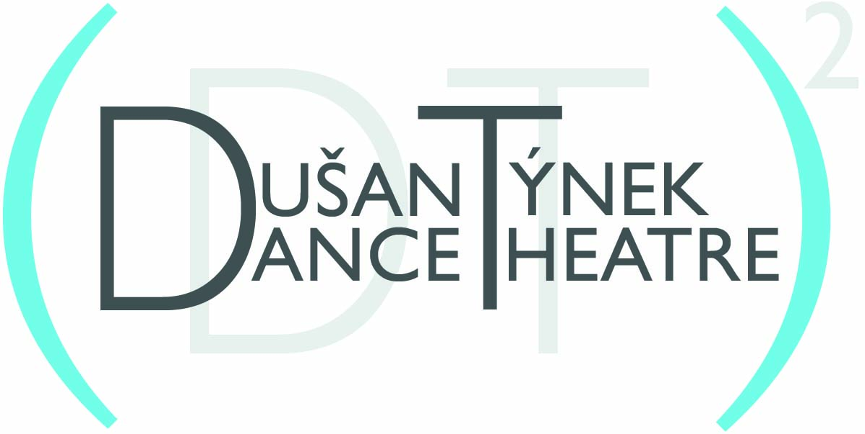

For Immediate Release
Press Contact: William Murray, 212.254.1357 or wilmurray@aol.com

July 16, 2013

Dušan Týnek Dance Theatre
Choreography by Dušan Týnek

10th Anniversary Performance Season

BAM Fisher (Fishman Space)
321 Ashland Place, Brooklyn, NY 11217

September 4-7, 2013 @ 7:30pm

Featuring Two World Premieres – “Stereopsis” and “Romanesco Suite” - with “Base Pairs” (2010)

“intelligent and inventive dancemaking” – Dance Magazine

"the work is marvelous ... Mr. Týnek is an undoubted talent, a choreographer who seems fascinated by movement itself and the strange, subtle ways in which it communicates strange, subtle things." - The New York Times

(Brooklyn, NY) -- Dušan Týnek Dance Theatre celebrates its 10th anniversary with a performance season September 4 - 7, 2013, at 7:30pm at the BAM Fisher, 321 Ashland Place, Brooklyn, NY 11217. The performances will also mark the culmination of the company’s participation in the inaugural year of BAM’s Professional Development Program, a professional training program led in collaboration with the DeVos Institute of Arts Management at the Kennedy Center. The program will include two world premieres and one repertory work – the unifying theme being an examination of the confluence of science and mythology. Though Mr. Týnek has gained much recognition for being a “musical” choreographer, the program will rely not on traditional musical instruments, but rather on an exploration of rhythms – percussive sounds and amplified footfall, breathing, and speech emanating from the dancers themselves – orchestrated in collaboration with sound designer Dave Ruder.
For ticket information call 718.636.4100 or go www.bam.org or www.dusantynek.org. Tickets are $20 with $16 discounted tickets for senior citizens, students and children under the age of 12.

More on the program’s three dances:

Stereopsis (World Premiere) visits the island of Cyclops in Homer’s Odyssey and explores the concept of “stereopsis” - the ability to perceive depth, usually requiring binocular disparity, although not necessarily in instances when an object is in motion. The dance is layered with an original text by Cynthia Poluntanovich that reworks Homer’s original.
Romanesco Suite (World Premiere) weaves a narrative out of the theory of fractals and its appearance in a philosophical theory of preformationism and the existence of homunculi. The dance is accompanied by a recording of the 17-year brood of cicadas that emerged in the summer of 2013 in the Northeastern U.S.
Base Pairs (2010), is inspired by origin stories and explores themes of Darwin’s evolutionary theory, the role of DNA on evolution and the incompatibility with creationism and biblical stories (e.g., the great flood and Noah’s Ark, Garden of Eden). The dance is accompanied only by a single, ticking metronome, the steadiness of which is contrasted by the dancers who embody the tempo and develop phrases in increasingly complex variations. Choreographed for eight performers, there are rarely more than one or two couples on stage at a time, inferring a larger dance that extends beyond the finite parameters of the stage, space, and time. Base Pairs incorporates an original text by Cynthia Polutanovich, performed by dance legend Lucinda Childs (recording).

Dušan Týnek Dance Theatre also announces its participation in DANCE GOTHAM/FOCUS 2014, January 10-12, 2014 at the Skirball Center for the Performing Arts (566 LaGuardia Place at Washington Square South, New York, NY 10012). The company will present Transparent Walls (2010), an excerpt from Trilogy – a collection of three dances to the music of Aleksandra Vrebalov that had its recent world premiere during a tour of Serbia in May 2013.

* * *

Dušan Týnek is known internationally for his striking blend of theatricality, musicality, and humanism in formally structured modern dance and has been called “an undoubted talent” by The New York Times. The Czech-born choreographer has studied and performed with several modern dance pioneers, owing much of his training and inspiration to Lucinda Childs as well as Merce Cunningham who personally tutored him while Týnek served as an understudy for the Merce Cunningham Dance Company. Týnek also performed and toured with Dance Works Rotterdam in the Netherlands. Since founding his own company in 2003, Týnek has created over 20 major dances, choreographed an opera, and held seven critically-acclaimed seasons in major dance venues in NYC. Týnek has received commissioning grants from the NEA and from the Harkness, Greenwall, and O’Donnell-Green Music and Dance foundations. He has taught and/or set work on students at schools across the U.S. and abroad. He is recently the recipient of a prestigious Bogliasco Fellowship. The company has received ongoing support from the Ford Foundation, NYCDCA, Czech Center NY, Trust for Mutual Understanding, and Mid Atlantic Arts Foundation, among others. For more information go to: www.dusantyenk.org

ALEXANDRA BERGER (dancer) is a founding company member of Dušan Týnek Dance Theatre. In addition to her continued work with Dušan, she has had the good fortune to work with, among others, Pat Catterson, Merce Cunningham (RUG 2007), and Matthew Westerby. She is a seasoned teacher of both Gyrotonic(R) and Gyrokinesis(R), and has taught modern dance technique combining these principles with Cunningham-based training in Florida, Massachusetts, Poland, and Russia. Alexandra holds a BFA from The New School.
ANN CHIAVERINI, (dancer) originally from Pittsburgh, PA, joined Dušan Týnek Dance Theatre in 2006. She has also had the privilege of working with The Met Opera, Bard Summerscape Opera, Edisa Weeks/Delirious Dance Company, Nancy Meehan Dance Company, and Stephan Koplowitz in New York, as well as Eisenhower Dance Ensemble and Michigan Opera Theatre in Detroit, MI. Ann holds a B.F.A. in Dance from The Joffrey Ballet School/New School University.
JOHN EIRICH (dancer) was raised in Orlando, Florida, earned his BFA in dance from New World School of the Arts in 2005 and was a student at Jacob's Pillow Contemporary Traditions Program. He has worked with the Amy Marshall Dance company, was a member of Taylor 2 from 2006-2010, and has been a member of TAKE Dance since 2007. John joined Dušan Týnek Dance Theatre in 2010, is currently a member of Dance Heginbotham, and has performed Missa Brevis with Limon Dance Company and L'Allegro and the Hard Nut with the Mark Morris Dance Group.
EMILY GAYESKI, (dancer) from Rochester, NY, received her B.F.A. from the North Carolina School of the Arts. She has performed with Carolyn Dorfman, bopi’s black sheep, Mark Morris Dance Group, and Isabel Gotzkowsky, among others. She has taught Pilates for over 10 years in the NYC area and is a volunteer in the physical therapy rehab unit at Methodist Hospital in Brooklyn. Emily joined Dušan Týnek Dance Theatre in 2009.
ELISA OSBORNE (dancer) currently dances with Dušan Týnek Dance Theatre (as a founding member), Patricia Hoffbauer, and Sally Silvers. She has performed with the Mark Morris Dance Group and currently teaches Pilates and dance in the MMDG school. She is a student of Irene Dowd, Kelly Slough, and Janet Panetta. She also teaches Pilates at Finetune Studio. She is grateful to Pat, Dušan, Irene, and her family.
NED STURGIS (dancer) is from Milwaukee, WI, and earned a BFA from University of Minnesota, Twin Cities where he performed in works by Maureen Flemming, Paul Taylor, Carl Flink, and Merce Cunningham. He was a member of TU Dance (Toni Pierce-Sands and Uri Sands), Theatre Forever, Twin Cities Ballet, Walker Art Center Momentum Dance Works, and Shapiro & Smith Dance. Ned has also shown his own choreography at the MN Fringe Festival. He joined Dušan Týnek Dance Theatre in 2012.
SAMUEL SWANTON (dancer) hails from Holden, Maine where he started dancing at the Robinson Ballet School. He attended The Walnut Hill School for the Arts and holds a BFA from NYU's Tisch School. Beyond Dušan Týnek Dance Theatre and Cherylyn Lavagnino Dance, he's had the pleasure of working with artists such as Pat Catterson, Patricia Hoffbauer, and Gus Solomons, Jr. Sam joined Dušan Týnek Dance Theatre in 2011.
TIMOTHY EMMETT LEE WARD (dancer) trained at the New Orleans Center for the Creative, and has a BFA in dance from Juilliard. He was a member of the Merce Cunningham Repertory Understudy Group and has performed with Douglas Dunn & Dancers, Pat Catterson, and many others. He also manages an Organic Avenue Boutique. Tim joined Dušan Týnek Dance Theatre in 2011.
RODERICK MURRAY (lighting designer) has been designing lighting and installations for performance both nationally and internationally since 1989. Murray has designed the lighting for all of Dušan Týnek’s works since 2003. Murray recently created an installation of light and light sculptures to reveal the architectural details of the famous Payne Whitney house in NYC. He recently designed the lighting and environment for violinist Tim Fain in his new multi-media work Portals. Murray has also designed the lighting and environments for all of Kimberly Bartosik's choreographic works, including her recent i like penises: a little something in 24 acts and ecsteriority.
CYNTHIA POLUTANOVICH (Text) recently received an M.F.A. in Creative Writing from Hunter College where she was a Hertog Fellow and is also working with Lis Harris, professor of creative writing at Columbia University and former New Yorker staff writer, as a research assistant on her latest book on Israeli/Palestinian history, culture, and politics. Cynthia has contributed work to Bloomsbury Review, No Go the Rickshaw, Half Drunk Muse, Tripwolf, and Killing the Buddha. Some years ago, she won the Academy of American Poets prize at the University of Nebraska. She is now in the process of writing a book about growing up in a trailer park, leaving home at 15, and eventually moving between states, living in school buses and chicken wire shacks. She has recently published her first novel: Corpses Rarely Wander: How I Became a Loveless Trailer Park Nomad.
DAVE RUDER (sound designer) is a range-y creative type, regularly working as a vocalist, clarinetist, guitarist, electronicist, composer, songwriter, writer/librettist, actor, mover, etc. Dave is a key member of the band Why Lie?, the storytelling project Dave & Woody’s Chicken Slaughtering LLC, and the ensembles Varispeed, Sweat Lodge, thingNY, and Gamelan Kusuma Laras. He also co-organizes Performers Forum at Exapno. He has regularly worked with Robert Ashley, Anthony Braxton, Kimberly Bartosik, Aaron Siegel, Andrew Lafkas (Eidolon), Abigail Levine, Joanna Kotze, and Panoply Performance Laboratory. For two years, Dave curated and ran the Flowering Inconsistencies performance series in Bushwick, Brooklyn. As a composer, his work has been featured in Experiments in Opera, and his WHY LIE? project, 100+ open scores, is available online. Dave holds degrees from Wesleyan University and Brooklyn College. Dave performs regularly and lives in NYC.
KAREN YOUNG (costume designer) has designed costumes for numerous dance and video art projects and has recently been teaching at Rhode Island School of Design. In addition to her work with Dušan Týnek Dance Theatre, her costume design for dance is in the repertories of the Martha Graham Dance Company, American Ballet Theater, Rioult, Keigwin + Company, Karole Armitage, Benjamin Millepied, Pam Tanowitz, Morphoses, and Third Rail Projects’ highly acclaimed Then She Fell, among many others. Costume design credits for video art include David Michalek’s Slow Dancing and Portraits in Dramatic Time (Lincoln Center Festival), Eve Sussman & the Rufus Corporation’s 89 Seconds at Alcazar and The Rape of the Sabine Women, and Matthew Barney’s Cremaster 5. Upcoming projects include Wendy Whelan’s Restless Creature and the new off-Broadway show Fighting Gravity. www.karenyoungcostume.com

The BAM Professional Development Program (BAM PDP) is a 14-month program that utilizes the strengths of both institutions to provide professional development training and deeply discounted theater and rehearsal studio rental to an annual selection of qualifying non-profit arts organizations. Through the program, supported by Brooklyn Community Foundation and The New York Community Trust, BAM and the DeVos Institute of Arts Management (DVIAM) at the Kennedy Center strive to help arts organizations expand their skill base, increase their institutional capacity, and build necessary foundations for their long-term success. The program culminates with each participating company presenting a self-funded production in the BAM Fisher’s Fishman Theater Space.
# # #
DT2BAMpressreleaseDraft 1docx 7.16.13

